

Functional Requirements Specification

Change Management

| Authors: | Bernice Templeman, Freddy Perez, Jaquina Porterfield, Michael Myers, Samuel Hagadorn |
| --- | --- |
| Approved by: | Prakash Agrawal |
| Version: | v3 |
| Date: | December 9, 2021 |
| Approved (Y/N): | Y |

**Table of Contents**

**1 Introduction** **4**

1.1 Background 4

1.2 Purpose 4

**2 Functionality Requirement** **5**

2.1 Form Design 5

2.1.1 Change Models 5

2.1.2 Create New Record (all models) 5

2.1.3 Change Request Task Form (all models) 7

2.1.4 Update Record 8

2.2 Form Fields 8

2.2.1 Create New Record 8

2.2.1.1 Planning Section 10

2.2.1.2 Schedule Section 11

2.2.1.3 Notes Section 12

2.2.2 Task Form Fields 12

2.2.3 Update Record Fields 13

2.2.3.1 Planning Section Form Fields 15

2.2.3.2 Schedule Section Form Fields 16

2.2.3.3 Notes Section Form Fields 17

2.3 Change Functionality 17

2.3.1 Change States 17

2.3.2 Change State Progress Matrix 18

2.3.2.1 Normal Change State Progress Matrix 18

2.3.2.2 Standard Change State Progress Matrix 18

2.3.2.3 Emergency Change Progress Matrix 18

2.3.2.4 Major Change Progress Matrix 19

2.3.3 Change Creation 19

2.3.3.1 Problem 19

2.3.3.2 Incident 19

2.3.3.3 CI 20

2.3.3.4 Copy Change Button 20

2.3.3.5 Manual 20

2.4 Change Lifecycle Walkthrough (Record States for All Changes) 21

2.4.1 New: Submitting a Change Request 22

2.4.2 Assess: Assessing a Change 22

2.4.3 Authorize: Requesting Approval for a Change 22

2.4.4 Scheduled: Authorizing a Change 22

2.4.5 Implement: Implementing a Change 22

2.4.6 Review: Reviewing a Change 22

2.4.7 Closed: Closing a Change 22

2.4.8 Cancel: Canceling a Change 23

2.5 Change Management Application and Modules 23

2.6 Change Management Views 24

**3 Form Fields (Tables)** **25**

3.1 New Change Record Table 25

3.1.1 Planning Section 27

3.1.2 Schedule Section 28

3.1.3 Conflicts Section 28

3.1.4 Notes Section 29

3.1.5 Closure Information 29

3.1.6 Choice List 29

3.2 Update Change Record Table 30

3.3 UI Changes 31

3.3.1 Nomenclature Changes 31

3.3.2 UI Policy (applied to change_request table) 32

3.3.3 UI Action (change_request) 36

3.3.4 Related Lists 38

3.4 Dictionary Entries 39

3.5 Scripting 39

3.5.1 Business Rules 39

3.5.2 Script Includes 40

3.5.3 Client Scripts 41

3.5.4 Data Lookup Change Request Priority 41

3.6 New Change Model: Major Change 42

3.6.1 Create a New Change Model 42

3.6.2 Major Change Request Tasks 42

3.7 Change Task Form 43

3.7.1 Notes Form Section 44

3.7.2 Closure Information Form Section 44

**4 Flow logic** **45**

4.1 Standard Change 45

4.1.1 Standard Change Flow 45

4.1.2 Standard Change Tasks 45

4.2 Emergency Change 46

4.2.1 Emergency Change Flow 46

4.2.2 Emergency Change Tasks 47

4.3 Normal Change 48

4.3.1 Normal Change Flow 48

4.3.2 Normal Change Tasks 48

4.4 Major Change 49

4.4.1 Major Change Flow 49

4.4.2 Major Change Task Flow 50

**5 Notifications** **51**

**6 Overview** **52**

6.1 Save Chart 53

6.2 Print Form 54

6.3 Print Change List 55

**7 References** **56**

# 

# 1 Introduction

## 1.1 Background

ServiceNow IT Service Management Template project includes customizing the out of the box (OOB) forms for Change Management to build a standard procedure to be used by any customer in a Single Tenant instance along with Notifications. It also includes the Functional Requirement Specification for Change Management per the ITIL standards. This project is a Blueprint which can be used in future for any fresh ServiceNow instances by applying the Update Sets.

Instance: <https://dev105680.service-now.com/>

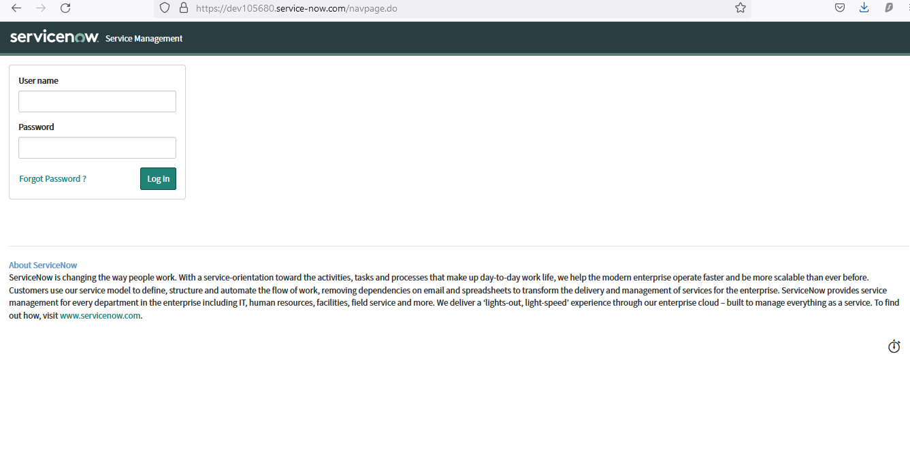

## 1.2 Purpose

This Functional Requirements Specification document will develop a repeatable step-by-step process to customize the ServiceNow Change Management. The customization process defined here will help enhance the customer’s ServiceNow experience.

# 2 Functionality Requirement

ServiceNow has the core functionalities necessary. We offer a more robust user experience and increased Change Management processes.

## 2.1 Form Design

### 2.1.1 Change Models

| **Type** | **Description** |
| --- | --- |
| Standard Change | A standard change is a pre-authorized change that is low risk, relatively common and follows a specified procedure or work instruction. These change requests are accessed through their own module in the left navigation. |
| Emergency Change | A change that must be implemented as soon as possible, for example to resolve an incident stopping service or to implement a critical security patch. This change is of such a high priority that it bypasses group and peer review and approval and goes straight to the Authorization state for approval by the Change Advisory Board. |
| Normal Change | Any service change that is not a standard change or an emergency change. |
| Major Change | A major change will substantially change the business operations. Because of the impact of the change, the planning stage is vast and more detailed than would be possible at the initial creation of the request. The Major Change Module expands the planning section by creating tasks for Implementation Plan, Risk and Impact Analysis, Backout Plan and Test Plan. |

### 

### 2.1.2 Create New Record (all models)

#### 

### 

2.1.4.1 Create New (Standard)

Because standard change requests are pre-defined, fields such as Change Category, Implementation Plan and Backout Plan are already know and are prefilled as much as possible.

### 

### 2.1.3 Change Request Task Form (all models)

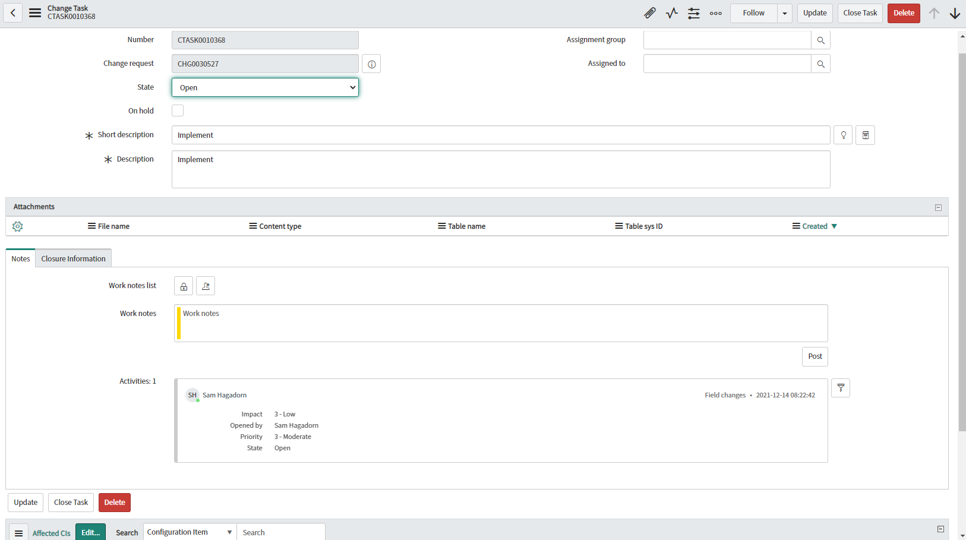

### 2.1.4 Update Record

## 2.2 Form Fields

### 2.2.1 Create New Record

| **Field** | **Type** | **Reference** | **Mandatory** | **Max Length** | **Read-Only** | **Default Values** | **Remarks** |
| --- | --- | --- | --- | --- | --- | --- | --- |
| Change ID | String | N/A | N | 40 | Y | javascript:getNextObjNumberPadded(); | System generated sequentially  Used to be Number |
| Request By | Reference | sys_user | N | 32 | Y | javascript:gs.getUserID() | Auto-populated by signed in user |
| Change Category | String | N/A | Y | 40 | N | Other | Choice List  -Database  -Hardware  -Network  -Other  -ServiceNow Deployment  -Software |
| Priority | Integer | N/A | N | 40 | Y | 3 | Choice List  3 - Medium |
| Urgency | Integer | N/A | N | 40 | N | 3 | Choice List  1 - High  2 - Medium  3 - Low |
| Business Impact | Integer | N/A | N | 40 | N | 3 | Choice List  1 - High  2 - Medium  3 - Low |
| Implementation Risk | Integer | N/A | N | 40 | N | 3 | Choice List  1 - High  2 - Medium  3 - Low |
| Model | Reference | chg_model | N | 32 | N | Major |  |
| State | Integer | N/A | N | 40 | N | New | Choice List |
| Working Group | Reference | sys_user_group | N | 32 | Y | Change Management | Populated from Change Model Major Record Presets |
| Assigned to | Reference | sys_user | N | 32 | N | N/A |  |
| Configuration item | Reference | cmdb_ci | N | 32 | N | N/A |  |
| Service | Reference | cmdb_ci_service | N | 32 | N | N/A |  |
| Service offering | Reference | service_offering | N | 32 | N | N/A |  |
| Short Description | String | N/A | Y | 160 | N | N/A |  |
| Detailed Description | String | N/A | N | 4000 | N | N/A |  |

#### 2.2.1.1 Planning Section

| **Field** | **Type** | **Reference** | **Mandatory** | **Max Length** | **Read-Only** | **Default Values** | **Remarks** |
| --- | --- | --- | --- | --- | --- | --- | --- |
| Justification | String | N/A | Y | 4000 | N | N/A |  |
| Implementation Plan | String | N/A | N | 4000 | N | N/A | Auto-Populate with Implementation Task Description when task is Closed |
| Risk and Impact | String | N/A | N | 4000 | N | N/A | Auto-Populate with Risk and Impact Task Description when task is Closed |
| Backout Plan | String | N/A | N | 4000 | N | N/A | Auto-Populate with Backout Plan Task Description when task is Closed |
| Test Plan | String | N/A | N | 4000 | N | N/A | Auto-Populate with Test Plan Task Description when task is Closed |

#### 2.2.1.2 Schedule Section

| **Field** | **Type** | **Reference** | **Mandatory** | **Max Length** | **Read-Only** | **Default Values** | **Remarks** |
| --- | --- | --- | --- | --- | --- | --- | --- |
| Planned Start Date | glide_date_time | N/A | Y | 40 | N | N/A |  |
| Planned End Date | glide_date_time | N/A | Y | 40 | N | N/A |  |
| Actual Start Date | glide_date_time | N/A | N | 40 | N | N/A |  |
| Actual End Date | glide_date_time | N/A | N | 40 | N | N/A |  |

#### 2.2.1.3 Notes Section

| **Field** | **Type** | **Reference** | **Mandatory** | **Max Length** | **Read-Only** | **Default Values** | **Remarks** |
| --- | --- | --- | --- | --- | --- | --- | --- |
| Additional Comments | journal_input | N/A | N | 4000 | N | N/A |  |
| Work Notes | Journal_input | N/A | N | 4000 | N | N/A |  |

### 2.2.2 Task Form Fields

| **Field** | **Type** | **Reference** | **Mandatory** | **Max Length** | **Read-Only** | **Default Values** | **Remarks** |
| --- | --- | --- | --- | --- | --- | --- | --- |
| Number | String | N/A | N | 40 | Y | javascript:getNextObjNumberPadded(); | System generated sequentially  Used to be Number |
| Change Request | Reference | change_request | N | 32 | Y | Current Change Request | Generated from the change request associated with the task |
| State | Choice List | N/A | N | 40 | N | 1 | Choice List  1 - Open  2 - In Progress  3 - Closed  4 - Canceled  -5 - Pending |
| On Hold | Boolean | N/A | N | 40 | N | false |  |
| Assignment Group | Reference | sys_user_group | N | 32 | N | N/A |  |
| Assigned to | Reference | sys_user | N | 32 | N | N/A | Dependent of Assignment Group |
| Short Description | String | N/A | Y | 160 | N | Dependent on Workflow | Workflow will generate the plans Short Description |
| Description | String | N/A | Y | 4000 | N | Dependent on Workflow | Workflow will generate the plans Description |
| Work Notes | String | N/A | N | 4000 | N | N/A |  |
| Close Notes | String | N/A | N | 4000 | N | N/A |  |

### 2.2.3 Update Record Fields

| **Field** | **Type** | **Reference** | **Mandatory** | **Max Length** | **Read-Only** | **Default Values** | **Remarks** |
| --- | --- | --- | --- | --- | --- | --- | --- |
| Change ID | String | N/A | N | 40 | Y | javascript:getNextObjNumberPadded(); | System generated sequentially  Used to be Number |
| Request By | Reference | sys_user | N | 32 | Y | javascript:gs.getUserID() | Auto-populated by signed in user |
| Change Category | String | N/A | Y | 40 | N | Other | Choice List  -Database  -Hardware  -Network  -Other  -ServiceNow Deployment  -Software |
| Priority | Integer | N/A | N | 40 | Y | 3 | Choice List  3 - Medium |
| Urgency | Integer | N/A | N | 40 | N | 3 | Choice List  1 - High  2 - Medium  3 - Low |
| Business Impact | Integer | N/A | N | 40 | N | 3 | Choice List  1 - High  2 - Medium  3 - Low |
| Implementation Risk | Integer | N/A | N | 40 | N | 3 | Choice List  1 - High  2 - Medium  3 - Low |
| Model | Reference | chg_model | N | 32 | N | Major |  |
| State | Integer | N/A | N | 40 | N | New | Choice List |
| Working Group | Reference | sys_user_group | N | 32 | Y | Change Management | Populated from Change Model Major Record Presets |
| Assigned to | Reference | sys_user | N | 32 | N | N/A |  |
| Configuration item | Reference | cmdb_ci | N | 32 | N | N/A |  |
| Service | Reference | cmdb_ci_service | N | 32 | N | N/A |  |
| Service offering | Reference | service_offering | N | 32 | N | N/A |  |
| Short Description | String | N/A | Y | 160 | N | N/A |  |
| Detailed Description | String | N/A | N | 4000 | N | N/A |  |

#### 2.2.3.1 Planning Section Form Fields

| **Field** | **Type** | **Reference** | **Mandatory** | **Max Length** | **Read-Only** | **Default Values** | **Remarks** |
| --- | --- | --- | --- | --- | --- | --- | --- |
| Justification | String | N/A | Y | 4000 | N | N/A |  |
| Implementation Plan | String | N/A | N | 4000 | N | N/A | Auto-Populate with Implementation Task Description when task is Closed |
| Risk and Impact | String | N/A | N | 4000 | N | N/A | Auto-Populate with Risk and Impact Task Description when task is Closed |
| Backout Plan | String | N/A | N | 4000 | N | N/A | Auto-Populate with Backout Plan Task Description when task is Closed |
| Test Plan | String | N/A | N | 4000 | N | N/A | Auto-Populate with Test Plan Task Description when task is Closed |

#### 2.2.3.2 Schedule Section Form Fields

| **Field** | **Type** | **Reference** | **Mandatory** | **Max Length** | **Read-Only** | **Default Values** | **Remarks** |
| --- | --- | --- | --- | --- | --- | --- | --- |
| Planned Start Date | glide_date_time | N/A | Y | 40 | N | N/A |  |
| Planned End Date | glide_date_time | N/A | Y | 40 | N | N/A |  |
| Actual Start Date | glide_date_time | N/A | N | 40 | N | N/A |  |
| Actual End Date | glide_date_time | N/A | N | 40 | N | N/A |  |

#### 2.2.3.3 Notes Section Form Fields

| **Field** | **Type** | **Reference** | **Mandatory** | **Max Length** | **Read-Only** | **Default Values** | **Remarks** |
| --- | --- | --- | --- | --- | --- | --- | --- |
| Additional Comments | journal_input | N/A | N | 4000 | N | N/A |  |
| Work Notes | Journal_input | N/A | N | 4000 | N | N/A |  |

## 2.3 Change Functionality

### 2.3.1 Change States

| **States** | **Description** |
| --- | --- |
| New | Saved, Not submitted for authorization or review. |
| Assess | Change details technical review |
| Authorized | CAB and Change Management team schedule change and give final authorization. |
| Scheduled | Fully scheduled and authorized awaiting planned start date notify the requestor. |
| Implement | Change implementation in progress notifies the requestor. |
| Review | Change implementation work is completed determining if change is successful. Notify requestor |
| Closed | Change implementation completely. |
| Canceled | Canceled and notified the requestor. |

### 2.3.2 Change State Progress Matrix

#### 2.3.2.1 Normal Change State Progress Matrix

|  | **New** | **Assess** | **Authorize** | **Scheduled** | **Implement** | **Review** | **Closed** | **Canceled** |
| --- | --- | --- | --- | --- | --- | --- | --- | --- |
| **New** |  | Y |  |  |  |  |  | Y |
| **Assess** | Y |  | Y |  |  |  |  | Y |
| **Authorized** | Y |  |  | Y |  |  |  | Y |
| **Scheduled** |  |  |  |  | Y |  |  | Y |
| **Implement** |  |  |  |  |  | Y |  | Y |
| **Review** |  |  |  |  | Y |  | Y |  |

#### 2.3.2.2 Standard Change State Progress Matrix

|  | **New** | **Assess** | **Authorize** | **Scheduled** | **Implement** | **Review** | **Closed** | **Canceled** |
| --- | --- | --- | --- | --- | --- | --- | --- | --- |
| **New** |  |  |  | Y |  |  |  | Y |
| **Scheduled** |  |  |  |  | Y |  |  | Y |
| **Implement** |  |  |  |  |  | Y |  | Y |
| **Review** |  |  |  |  | Y |  | Y |  |

#### 2.3.2.3 Emergency Change Progress Matrix

|  | **New** | **Assess** | **Authorize** | **Scheduled** | **Implement** | **Review** | **Closed** | **Canceled** |
| --- | --- | --- | --- | --- | --- | --- | --- | --- |
| **New** |  |  | Y |  |  |  |  | Y |
| **Authorized** | Y |  |  | Y |  |  |  | Y |
| **Scheduled** |  |  |  |  | Y |  |  | Y |
| **Implement** |  |  |  |  |  | Y |  | Y |
| **Review** |  |  |  |  | Y |  | Y |  |

#### 2.3.2.4 Major Change Progress Matrix

|  | **New** | **Assess** | **Authorize** | **Scheduled** | **Implement** | **Review** | **Closed** | **Canceled** |
| --- | --- | --- | --- | --- | --- | --- | --- | --- |
| **New** |  | Y |  |  |  |  |  | Y |
| **Assess** | Y |  | Y |  |  |  |  | Y |
| **Authorized** | Y |  |  | Y |  |  |  | Y |
| **Scheduled** |  |  |  |  | Y |  |  | Y |
| **Implement** |  |  |  |  |  | Y |  | Y |
| **Review** |  |  |  |  | Y |  | Y |  |

### 2.3.3 Change Creation

Change requests are created either manually or from a problem, incident, or CI.

#### 2.3.3.1 Problem

To create a change request from a problem go to the problem record Problem > Open. Open the context menu and select either create normal change or create emergency change.

#### 2.3.3.2 Incident

To create a change from an incident, navigate to **Workspace Experience** > **Workspaces** > **Agent Workspace Home**.

1. From the list, click **Incidents** > **Open**.
2. Open the incident record from which you want to create a change.
3. Click the more actions icon (More actions icon)

#### 2.3.3.3 CI

To create a change from a CI, You can create a change request from a list of CIs, or add selected CIs from a list to a change record.

1. Select a list of CIs. For example, navigate to **Configuration** > **Servers** > **Unix**.
2. Select one or more CIs from the list.
3. Select one of the following options from the **Actions** list.

| **Option** | **Description** |
| --- | --- |
| Add to existing Change Request | Select this option to associate the CIs with an existing change request. |
| Add to new Change Request | Select this option to associate the CIs with a new change request. |

#### 2.3.3.4 Copy Change Button

You can copy details of an active or canceled change request to a new change request.

#### 2.3.3.5 Manual

To manually create a change request, go to the Change App> Create New and choose change type.

Standard changes can be created through the Change App > Standard Change > Standard Change Catalog.

Standard Change Catalog

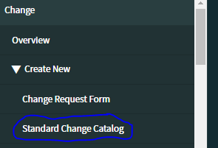

Standard Change Requests

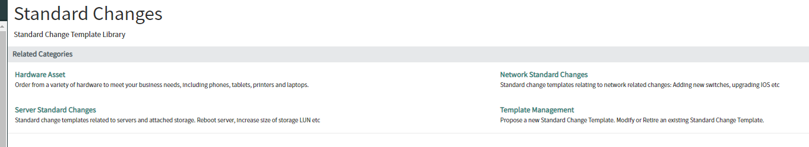

Standard Change Requests - Server

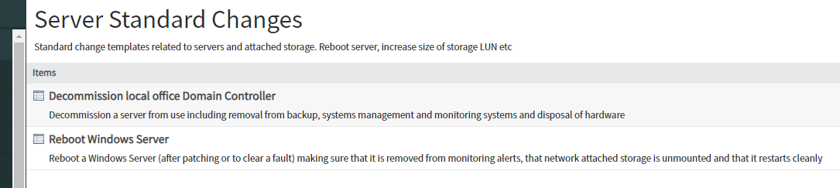

## 2.4 Change Lifecycle Walkthrough (Record States for All Changes)

ServiceNow Change Management adds a systematic way to control the life cycle of all changes. Change Management facilitates the change process with minimal disruption to IT services (ServiceNow, 2021). Each change may not go through all stages of the life cycle.

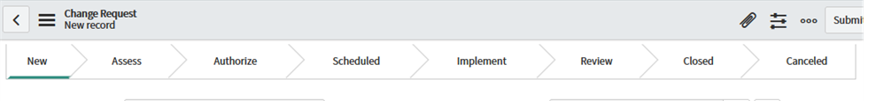

### 2.4.1 New: Submitting a Change Request

A change request is created by an individual or a group of people. Change request is not yet submitted for review and authorization. A change requester can save a change request as many times as necessary while building out the details of the change prior to submission.

### 2.4.2 Assess: Assessing a Change

Peer review and technical approval of the change details are performed during this state. (Skipped in emergency and standard requests.)

### 2.4.3 Authorize: Requesting Approval for a Change

Change Management and the CAB schedule the change and provide final authorization to proceed. (Skipped in standard requests.)

### 2.4.4 Scheduled: Authorizing a Change

The change is fully scheduled and authorized, and is waiting for the planned start date. An email notification is sent to the user who requested the change.

### 2.4.5 Implement: Implementing a Change

The planned start date has approached and the actual work to implement the change is being conducted. An email notification is sent to the user, who requested the change. Change tasks are created to confirm implementation and testing.

### 2.4.6 Review: Reviewing a Change

The work has been completed. The change requester determines whether the change was successful. A post-implementation review can be conducted during this state. An email notification is sent to the user who requested the change. You cannot cancel the change request if it is in the Review state.

### 2.4.7 Closed: Closing a Change

All review work is complete. The change is closed with no further action required.

### 2.4.8 Cancel: Canceling a Change

A change can be canceled at any point when it is no longer required. However, a change cannot be canceled from a **Closed** state. An email notification is sent to the user who requested the change.

## 2.5 Change Management Application and Modules

In the Application Navigator, it lets us access the applications and modules of ServiceNow. To access the modules for Change Requests you must enter change into the application navigator. Once entered it will give you access to the change application. In the change application it has many modules including Create New,Open, Closed, All, Standard Change, Change Advisory Board, and etc.

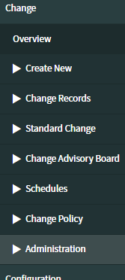

| **Module** | **Brief Description** |
| --- | --- |
| Overview | Dashboard with counts, graphs and calender for quick reference |
| Create New | Create all new change requests, Standard change requests are through included Standard Change Catalog |
| Change Records | Access already created change request records |
| Standard Change | Access standard change templates |
| Change Advisory Board | Access CAB modules |
| Schedules | Access schedule rules and definitions |
| Change Policy | Workflows and definitions based on business rules |
| Administration | Define models, properties and conditions, also access ATF suite |

## 2.6 Change Management Views

Change request form views include Approval, cab_workbench, Default view, Emergency, Mobile, Sys_popup, and Workspace.

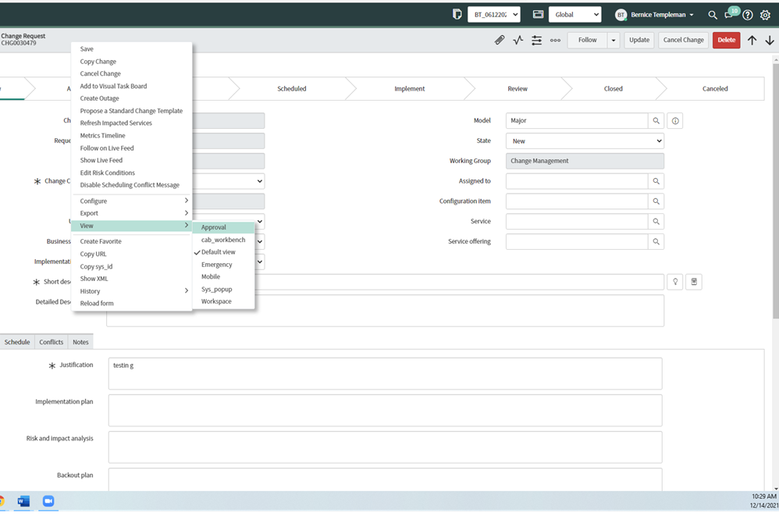

# 

# 3 Form Fields (Tables)

## 3.1 New Change Record Table

| **Field** | **Type** | **Reference** | **Mandatory**  **(Y/N)** | **Max Length** | **Read-Only** | **Default Values** | **Remarks** |
| --- | --- | --- | --- | --- | --- | --- | --- |
| Change ID | String | N/A | N | 40 | Y | javascript:getNextObjNumberPadded(); | System generated sequentially  Used to be Number |
| Requested By | Reference | sys_user | N | 32 | Y | javascript:gs.getUserID() | auto -populated by signed in user |
| Change Category | String | N/A | N | 40 | N | Other | Choice List |
| Service | Reference | cmdb_ci_service | N | 32 | N | N/A |  |
| Service Offering | Reference | service_offering | N | 32 | N | N/A |  |
| Configuration Item | Reference | cmdb_ci | N | 32 | N | N/A |  |
| Implementation Risk | Integer | N/A | N | 40 | N | 3 | Use to be risk |
| Business Impact | Integer | N/A | N | 40 | N | 3 | Use to be impact |
| Urgency | Integer | N/A | N | 40 | N | 3 | Add |
| Priority | Integer | N/A | N | 40 | N | 4 | Choice List:  Make read only if Emergency model;  Only emergency change sets P1;  Default setting 3 for Major, 2 for Standard |
| Model | Reference | chg_model | N | 32 | N | javascript:ChangeModel.getDefaultModelValue() |  |
| Type | String | N/A | N | 40 | Y | javascript:ChangeModel.getDefaultTypeValue() | Auto-populated by system |
| State | Integer | N/A | N | 40 | Y | 1 | Choice list |
| Conflict Status | String | N/A | N | 40 | Y | Not Run | Auto-populated by Conflict detection |
| Conflict Last Run | Date/Time | N/A | N | 40 | Y | N/A | Auto-populated by conflict detection |
| Working Group | Reference | sys_user_group | N | 32 | N | N/A | Use to be Assigned Group |
| Assigned To | Reference | sys_user | N | 32 | N | N/A |  |
| Short Description | String | N/A | N | 160 | N | N/A |  |
| Detailed Description | String | N/A | N | 4000 | N | N/A | Use to be description |

### 

| **Label** | **Choices** |
| --- | --- |
| Change Category | Hardware, Software, Service, System Software,  Applications Software, Network, Telecom, Documentation, Other |
| Business Impact | 1 - High, 2 - Medium, 3 - Low |
| Urgency | 1 - High, 2 - Medium, 3 - Low |
| Priority | 1- Critical, 2 - High, 3 - Moderate, 4 - Low |
| Implementation Risk | Low, Moderate, High |

### 

### 3.1.1 Planning Section

| **Field** | **Type** | **Reference** | **Mandatory**  **(Y/N)** | **Max Length** | **Read-Only** | **Default Values** |
| --- | --- | --- | --- | --- | --- | --- |
| Justification | String | N/A | Y in the Assess state | 500 | N | N/A |
| Implementation Plan | String | N/A | Y in the Assess state | 4000 | N | N/A |
| Risk and Impact Analysis | String | N/A | N | 4000 | N | N/A |
| Backout Plan | String | N/A | Y in the Assess state | 4000 | N | N/A |
| Test Plan | String | N/A | N | 4000 | N | N/A |

### 3.1.2 Schedule Section

| **Field** | **Type** | **Reference** | **Mandatory**  **(Y/N)** | **Max Length** | **Read-Only** | **Default Values** |
| --- | --- | --- | --- | --- | --- | --- |
| Planned Start Date | glide_date_time | N/A | Y in the Assess state | 40 | N | N/A |
| Planned End Date | glide_date_time | N/A | Y in the Assess state | 40 | N | N/A |
| CAB Required | Boolean | N/A | N | 40 | N | false |
| CAB Date | glide_date | N/A | N | 40 | N | N/A |
| Actual Start Date | glide_date_time | N/A | N | 40 | N | N/A |
| Actual End Date | glide_date_time | N/A | N | 40 | N | N/A |
| CAB Delegate | reference | sys_user | N | 32 | N | N/A |
| CAB Recommendation | String | N/A | N | 4000 | N | N/A |
| CAB Outcome | String | N/A | Y in Assess state if CAB Required is True | 40 | N | N/A |
| Visible Revision | Integer | N/A | Y in Assess state if CAB required is True | 40 | N | 1 |

### 3.1.3 Conflicts Section

| **Field** | **Type** | **Reference** | **Mandatory**  **(Y/N)** | **Max Length** | **Read-Only** | **Default Values** |
| --- | --- | --- | --- | --- | --- | --- |
| Check Conflicts | Formatter | N/A | N | N/A | N | N/A |
| Conflicts Detected | Embedded List | N/A | N | N/A | N | N/A |

### 3.1.4 Notes Section

| **Field** | **Type** | **Reference** | **Mandatory**  **(Y/N)** | **Max Length** | **Read-Only** | **Default Values** | **Remarks** |
| --- | --- | --- | --- | --- | --- | --- | --- |
| Watch List | glide_list | sys_user | N | 4000 | N | N/A |  |
| Work Notes List | glide_list | sys_user | N | 4000 | N | N/A |  |
| Work Notes | Journal | N/A | Y in the Implement State | 4000 | N | Work notes |  |
| Activities | Formatter | N/A | N | N/A | Y | N/A | System count of past activity on record |

### 3.1.5 Closure Information

| **Field** | **Type** | **Reference** | **Mandatory**  **(Y/N)** | **Max Length** | **Read-Only** | **Default Values** |
| --- | --- | --- | --- | --- | --- | --- |
| Close Code | String | N/A | Y on Implement State | 40 | N | N/A |
| Close Notes | String | N/A | Y on Implement State | 4000 | N | N/A |

### 3.1.6 Choice List

| **Label** | **Choices** |
| --- | --- |
| Close Code | Successful, Successful with Issues, Unsuccessful |

### 

## 3.2 Update Change Record Table

| **Field** | **Type** | **Reference** | **Mandatory**  **(Y/N)** | **Former Max Length** | **New Max Length** | **Default Values** |
| --- | --- | --- | --- | --- | --- | --- |
| Change ID | String | N/A | N | 40 | Y | javascript:getNextObjNumberPadded(); |
| Requested By | Reference | sys_user | N | 32 | Y | javascript:gs.getUserID() |
| Change Category | String | N/A | N | 40 | N | Other |
| Service | Reference | cmdb_ci_service | N | 32 | N | N/A |
| Service Offering | Reference | service_offering | N | 32 | N | N/A |
| Configuration Item | Reference | cmdb_ci | N | 32 | Y | N/A |
| Implementation Risk | Integer | N/A | N | 40 | N | 3 |
| Business Impact | Integer | N/A | N | 40 | N | 3 |
| Urgency | Integer | N/A | N | 40 | N | 3 |
| Priority | Integer | N/A | N | 40 | Y | 4 |
| Model | Reference | chg_model | N | 32 | Y | javascript:ChangeModel.getDefaultModelValue() |
| Type | String | N/A | N | 40 | Y | javascript:ChangeModel.getDefaultTypeValue() |
| State | Integer | N/A | N | 40 | Y | 1 |
| On Hold | True/False | N/A | N | 40 | N | False |
| Conflict Status | String | N/A | N | 40 | Y | Not Run |
| Conflict Last Run | Date/Time | N/A | N | 40 | Y | N/A |
| Working Group | Reference | sys_user_group | Y | 32 | N | N/A |
| Assigned To | Reference | sys_user | N | 32 | N | N/A |
| Short Description | String | N/A | N | 160 | N | N/A |
| Detailed Description | Sring | N/A | N | 4000 | N | N/A |

## 3.3 UI Changes

### 3.3.1 Nomenclature Changes

From the “Out-of-the-Box” ServiceNow platform some of the nomenclature is not specific enough for some users. We customized the nomenclature for some fields to better clarify the purpose of the field and what the value it has represents.

| **Prior Column Label** | **Custom Column Label** |
| --- | --- |
| Number(Dictionary Override) | Change ID |
| Category(Dictionary Override) | Change Category |
| Description(Dictionary Override) | Detailed Description |
| Assignment Group(Dictionary Override) | Working Group |
| Risk | Implementation RIsk |
| Impact(Dictionary Override) | Business Impact |

### 3.3.2 UI Policy (applied to change_request table)

UI policies dynamically change the behavior of fields on a form. For example, you can use UI policies to make the number field on a form read-only, make the short description field mandatory, and hide other fields. Basic UI policies do not require any scripting, however for more advanced actions, use the run scripts option. You can also use client scripts to perform all of these actions, but for faster load times use UI policies when possible. (ServiceNow, 2021).

| **New Change Request Form** | | | | | |
| --- | --- | --- | --- | --- | --- |
| **Global** | **On Load** | **Field** | **Change** | **Filter Conditions** | **Remarks** |
| Yes | Yes | Change ID | Read Only=True | none | Custom label |
| Yes | Yes | Requested By | Read Only=True | none | Logged in user |
| Yes | Yes | Change Category | Mandatory=True | none | Custom label |
| Yes | Yes | Priority | Read only based on Model | none | Emergency = 1, Normal default 3, Major default 3, Standard default 2 |
| Yes | Yes | State | Read Only=True | none | Set in workflow |
| Yes | Yes | Short Description | Mandatory=True | none |  |
| Yes | Yes | Type | Visible=False | none |  |
| Yes | Yes | Detailed Description | Mandatory=False | none | Custom label |
| Yes | Yes | Email | Read Only=True | none | Populated in CS |
| Yes | Yes | Conflict Status | Visible=False | none |  |
| Yes | Yes | Conflict Last Run | Visible=False | none |  |
| Yes | Yes | Working Group | Read Only=True | none | Custom label;  Set by business rule |
| Yes | Yes | CAB Date | Hidden=True | CAB Required is empty or false |  |
| Yes | Yes | Visible Revision | Hidden=True | CAB Required is empty or false |  |
| Yes | Yes | Planned Start Date | Validation | Date not less than today |  |
| Yes | Yes | Implementation Plan | Mandatory=True | Created is not empty | Fields mandatory after record is inserted |
| Yes | Yes | Test Plan | Mandatory=True | Created is not empty | Fields mandatory after record is inserted |
| Yes | Yes | Risk Impact Analysis | Mandatory=True | Created is not empty | Fields mandatory after record is inserted |
| Yes | Yes | Backout Plan | Mandatory=True | Created is not empty | Fields mandatory after record is inserted |

| **Assess State** | | | | | |
| --- | --- | --- | --- | --- | --- |
| **Global** | **On Load** | **Field** | **Change** | **Filter Conditions** | **Remarks** |
| Yes | No | Justification | Mandatory=True | State is Assess |  |
| Yes | No | Check Conflicts | Mandatory=True | State is Assess |  |
| Yes | No | Planned Start Date | Mandatory=True | State is Assess |  |
| Yes | No | Planned End Date | Mandatory=True | State is Assess |  |
| Yes | Yes | Implement Plan, Risk Impact Analysis, Backout Plan Test Plan | Mandatory = True | State is New  Model is Major | Adds placeholder text for Major Change |

| **Scheduled State** | | | | | |
| --- | --- | --- | --- | --- | --- |
| **Global** | **On Load** | **Field** | **Change** | **Filter Conditions** | **Remarks** |
| Yes | No | Justification | Read Only=True | State is one of Scheduled, Implement, Review, Closed or Canceled | Mandatory in prior state |
| Yes | No | Implementation Plan | Read Only=True | State is one of Scheduled, Implement, Review, Closed or Canceled | Mandatory in prior state |
| Yes | No | Risk and Impact Analysis | Read Only=True | State is one of Scheduled, Implement, Review, Closed or Canceled | Mandatory in prior state |
| Yes | No | Backout Plan | Read Only=True | State is one of Scheduled, Implement, Review, Closed or Canceled | Mandatory in prior state |
| Yes | No | Test Plan | Read Only=True | State is one of Scheduled, Implement, Review, Closed or Canceled | Mandatory in prior state |

| **Implement State** | | | | | |
| --- | --- | --- | --- | --- | --- |
| **Global** | **On Load** | **Field** | **Change** | **Filter Conditions** | **Remarks** |
| Yes | No | Work Notes | Mandatory=True | State is Implement |  |

| **Review State** | | | | | |
| --- | --- | --- | --- | --- | --- |
| **Global** | **On Load** | **Field** | **Change** | **Filter Conditions** | **Remarks** |
| Yes | No | Close Code | Mandatory=True | State is Review |  |
| Yes | No | Close Notes | Mandatory=True | State is Review |  |

| **Closed State** | | | | | |
| --- | --- | --- | --- | --- | --- |
| **Global** | **OnLoad** | **Field** | **Change** | **Filter Conditions** | **Remarks** |
| Yes | No | All fields except detailed description and additional notes | Read-Only=True | State is Closed/Cancelled |  |

#### 3.3.2.1 UI Policy Change Tasks

| **Update Change Task Form** | | | | | |
| --- | --- | --- | --- | --- | --- |
| **Global** | **On Load** | **Field** | **Change** | **Filter Conditions** | **Remarks** |
| Yes | Yes | Assigned To | Read Only=True | none | Auto-populated cannot change |
| Yes | Yes | Assignment Group | Visible=False | none | Not Needed using assigned to |
| Yes | Yes | Short Description | Read only = true | none |  |

### 3.3.3 UI Action (change_request)

UI actions include the buttons, links, and context menu items on forms and lists. Configure UI actions to make the UI more interactive, customized, and specific to user activities.(ServiceNow, 2021).

The following table contains all the UI actions for change_request at this time.

| **Name** | **UI Action** | **Description** | **Remarks** |
| --- | --- | --- | --- |
| Cancel change | Cancel Button | Customized banner button on the form that places change into a canceled state. | Updated Cancel Change. Table change_request. Add Form Button |
| Revert to New | Form Context menu | Pull a change back to the new state to make updates without having to copy/cancel |  |
| Conflict Calendar | Form button | Shows calendar view |  |
| Disable Scheduling Conflict Message | Form context menu | Disable showing message when scheduling conflict is detected |  |
| schedule | Form button | Progresses change to Scheduled state |  |
| Refresh impacted services | Form context menu | Refresh list of Business Services impacted by the associated CI |  |
| Create outage | Workspace form menu | Create an outage record to track the duration of down time or degradation of service |  |
| Review | Form Button | Progresses change to Review state |  |
| Workflow context | Form link |  |  |
| Copy Change | Form Context menu | Copies current change record and redirects to the new unsaved change |  |
| Implement | Form Button | Progresses change to Implement state |  |
| Request Approval | Form button | Progresses change to the Assess state |  |
| Calculate Risk | Calculate Risk | Calculates the risk of the current change based on risk and impact. | Form link |
| New | List Banner Button | Related Lists |  |
| Create Change Task | Workspace Form Menu | Create a change task against the current change request |  |
| Show Flow | Form Link |  |  |
| Apply Proposed Changes | Form Button |  |  |
| Edit Risk Conditions | Form Context menu |  |  |
| New | List banner Button | Normal lists |  |
| Add | List Banner button |  |  |
| Show workflow | Form link |  |  |
| Propose a standard change template | Form context menu | Propose a standard change template from the current Change Request. |  |
| Create Outage | Form Context menu | Create an outage record to track the duration of down time or degradation of service |  |
| Request Approval | Form button | Progresses change to the Authorize state |  |
| Assign to me | List context menu |  |  |
| Enable scheduling a conflict message | Form context menu | Enable showing message when scheduling conflict is detected |  |
| Close | Form button | Progresses change to Close state |  |

### 3.3.4 Related Lists

| **List Name** | **Description** | **Remarks** |
| --- | --- | --- |
| Affected CIs | List that displays configuration items that are affected by the change. |  |
| Impacted Services/CIs | List that displays the configuration items and services impacted by the change. |  |
| Approvers | Shows the CAB board and approval status from each. |  |
| Change Tasks | List of all the change tasks related to the change |  |
| Problems | Links to the problem table |  |
| Incidents Fixed by Change | List of incidents that are resolved by the actions taken in the change. |  |
| Incidents Caused by Change | List of incidents caused by the actions taken in the change. |  |
| Task SLAs | Service Level Agreements related to the change. |  |
| Outages | List of known outages in the system/CIs related to the change. |  |

## 3.4 Dictionary Entries

| Table | Name | Type | Default Value | Options |
| --- | --- | --- | --- | --- |
| change_request | CAB Outcome | Choice List | -None- | -Approved  -Rejected  -Revised |
| change_request | Visible Revision | Integer | 1 | N/A, set by turnstyle count in workflow |

## 3.5 Scripting

### 3.5.1 Business Rules

Business Rules are server-side logic that execute when database records are queried, updated, inserted, or deleted. Business Rules respond to database interactions regardless of access method: for example, users interacting with records through forms or lists, web services, or data imports (configurable). (ServiceNow, 2021).

| **Name** | **When** | **Filter Condition** | **Action** |
| --- | --- | --- | --- |
| Change Request-Change Category Hardware | Before Insert and update | Change Category is Hardware | Set field values Working Group to Hardware |
| Change Request-Change Category Software | Before Insert and update | Change Category is Software | Set field values Working Group to Software |
| Change request change category Service | Before Insert and update | Change Category is Service | Set field values Working Group to Service |
| Change request change category System Software | Before Insert and update | Change Category is System Software | Set field values Working Group to System Software |
| Change Request-Change Category App Soft | Before insert and update | Change category is Applications software | Set field values Working Group to App Software |
| Change Request-Change Category Network | Before insert and update | Change category is Network | Set field values Working Group to Network |
| Change Request-Change Category Telecom | Before insert and update | Change category is Telecom | Set field values Working Group to Telecom |
| Change Request-Change Category Other | Before insert and update | Change category is other | Set field values Working Group to Other |
| Set fields Planning Section From Tasks | After Update | State changes to Closed or Description Changes | Script : Set the values on change request from the change tasks. |
| Make Implement On Hold | Before Update | State is implement | Script |
| Set Change Task Assignment | Display | State is open | Script : Set planning task (assigned to) to the change request (requested by) implement and testing task set to change request (assigned to) |

### 3.5.2 Script Includes

Script Includes are reusable server-side script logic that define a function or class. Script Includes execute their script logic only when explicitly called by other scripts. There are different types of Script Includes:

* On demand/classless
* Extend an existing class
* Define a new class (ServiceNow, 2021).

| **Name** | **Description** | **Client Callable** | **Remarks** |
| --- | --- | --- | --- |
| changeRequestStateModel_major | This script includes represents the state model for major changes. |  | Defines state transitions and control the transitioning between states for a major change |
| [ChangeRequestStateHandler](https://dev105680.service-now.com/sys_script_include.do?sys_id=7d127e37cb100200d71cb9c0c24c9cff&sysparm_record_target=sys_script_include&sysparm_record_row=2&sysparm_record_rows=114&sysparm_record_list=nameCONTAINSchange%5EORDERBYDESCsys_updated_on) | This script include controls the transitioning between states using one of the defined models to determine which transitions are allowed. |  |  |
| ChangeRequestStateModelSNC_major |  |  |  |

### 3.5.3 Client Scripts

| **Type** | **Name** | **Action** |
| --- | --- | --- |
| onLoad | StateScheduledRO | When the form enters the scheduled state, it would make the fields in Schedule Planned Start Date and Planned End Date read only. |
| onChange | Closure Tab only on Review/Closed/Cancel | On the change request form, there is a form section closure information. We made that form section hidden until needed in the Review, Closed, and Cancelled states. |

### 3.5.4 Data Lookup Change Request Priority

Since we have a priority field in the change request it was only fair to make it uniform with incidents where priority is set by impact and urgency. Out of the box on the change request form it did not change priority based on impact and urgency so we implemented a data lookup. Now it sets priority based on Business Impact and Urgency.

| **Business Impact** | **Urgency** | **Priority** |
| --- | --- | --- |
| 1 - High | 1 - High | 1 - Critical |
| 1 - High | 2 - Medium | 2 - High |
| 1 - High | 3 - Low | 3 - Moderate |
| 2 - Medium | 1 - High | 2 - High |
| 2 - Medium | 2 - Medium | 3 - Moderate |
| 2 - Medium | 3 - Low | 4 -Low |
| 3 - Low | 1 - High | 3 - Moderate |
| 3 - Low | 2 - Medium | 4 - Low |
| 3 - Low | 3 - Low | 4 - Low |

## 3.6 New Change Model: Major Change

### 3.6.1 Create a New Change Model

| **Field** | **Type** | **Value** |
| --- | --- | --- |
| Name | String | Major |
| Default Change Model | Boolean | False |
| Active | Boolean | True |
| Available in ‘Create New’ | Boolean | True |
| Description | String | Major Change |
| Record Preset | Template_value | Type = Major Change  Priority = 3 - Moderate  Working Group = Change Management |

### 3.6.2 Major Change Request Tasks

| **State** | **Task** | **Remarks** |
| --- | --- | --- |
| Assess | Major Change Implementation | Generated by workflow |
| Assess | Risk and Impact Analysis | Generated by workflow |
| Assess | Major Change Test Plan | Generated by workflow |
| Assess | Major Change Backout Plan | Generated by workflow |
| Implement | Implementation | Generated by workflow |
| Implement | Testing | Generated by workflow |

## 3.7 Change Task Form

## 

| **Field** | **Type** | **Reference** | **Mandatory**  **(Y/N)** | **Max Length** | **Read-Only** | **Default Values** | **Remarks** |
| --- | --- | --- | --- | --- | --- | --- | --- |
| Change ID | String | N/A | N | 40 | Y | javascript:getNextObjNumberPadded(); | System generated from change request |
| Change Request | Reference | change_request | N | 32 | Y | javascript:gs.getUserID() | auto -populated by change request |
| Configuration Item | Reference | cmdb_ci | N | 32 | N | N/A |  |
| Planned Start Date | glide_date_time | N/A | Y in the Assess state | 40 | N | N/A |  |
| Planned End Date | glide_date_time | N/A | Y in the Assess state | 40 | N | N/A |  |
| Type | String | N/A | N | 40 | Y | javascript:ChangeModel.getDefaultTypeValue() | Auto-populated by system |
| State | Integer | N/A | N | 40 | Y | 1 | Choice list |
| On Hold | Boolean | N/A | N | 40 | N | False |  |
| Working Group | Reference | sys_user_group | N | 32 | N | N/A | Use to be Assigned Group |
| Assigned To | Reference | sys_user | N | 32 | N | N/A |  |
| Short Description | String | N/A | N | 160 | N | N/A |  |
| Detailed Description | String | N/A | N | 4000 | N | N/A | Use to be description |

### 3.7.1 Notes Form Section

| **Field** | **Type** | **Reference** | **Mandatory**  **(Y/N)** | **Max Length** | **Read-Only** | **Default Values** | **Remarks** |
| --- | --- | --- | --- | --- | --- | --- | --- |
| Work Notes List | glide_list | sys_user | N | 4000 | N | N/A |  |
| Work Notes | Journal | N/A | Y in the Implement State | 4000 | N | N/A |  |

### 

### 3.7.2 Closure Information Form Section

| **Field** | **Type** | **Reference** | **Mandatory**  **(Y/N)** | **Max Length** | **Read-Only** | **Default Values** |
| --- | --- | --- | --- | --- | --- | --- |
| Close Notes | String | N/A | Y on Implement State | 4000 | N | N/A |

# 4 Flow logic

## 4.1 Standard Change

### 4.1.1 Standard Change Flow

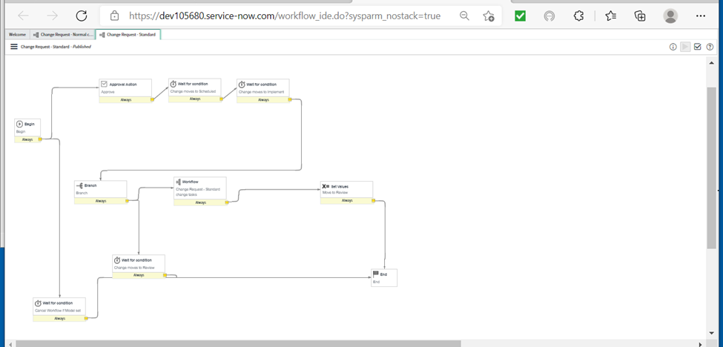

### 4.1.2 Standard Change Tasks

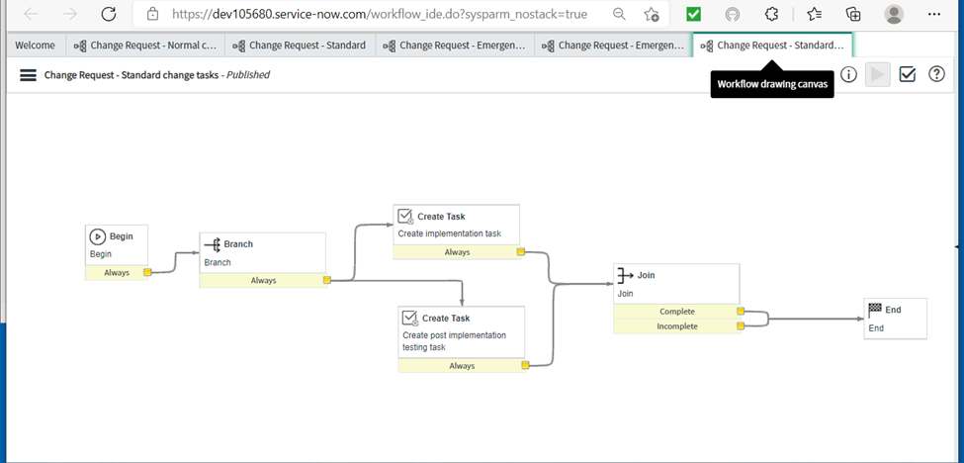

## 4.2 Emergency Change

### 4.2.1 Emergency Change Flow

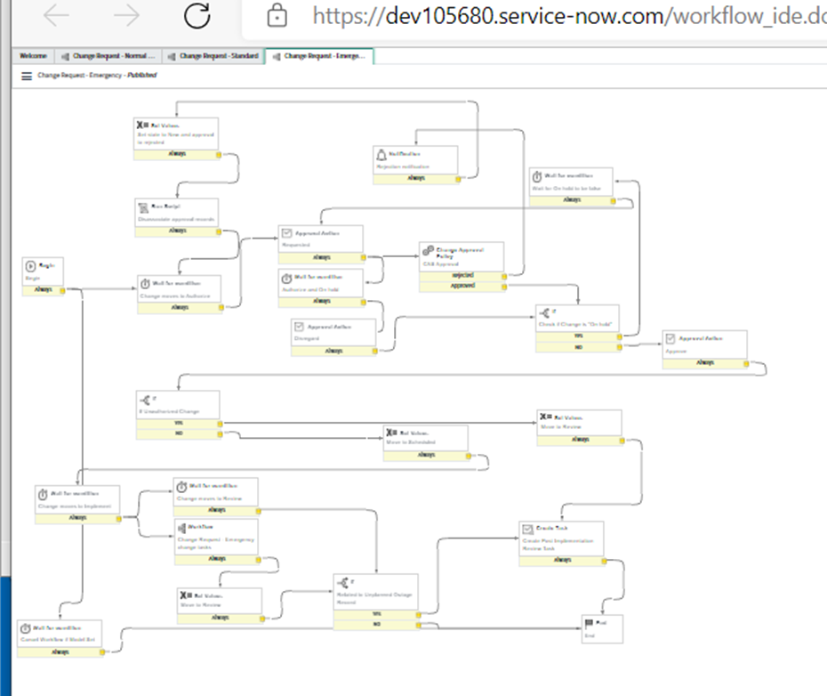

### 4.2.2 Emergency Change Tasks

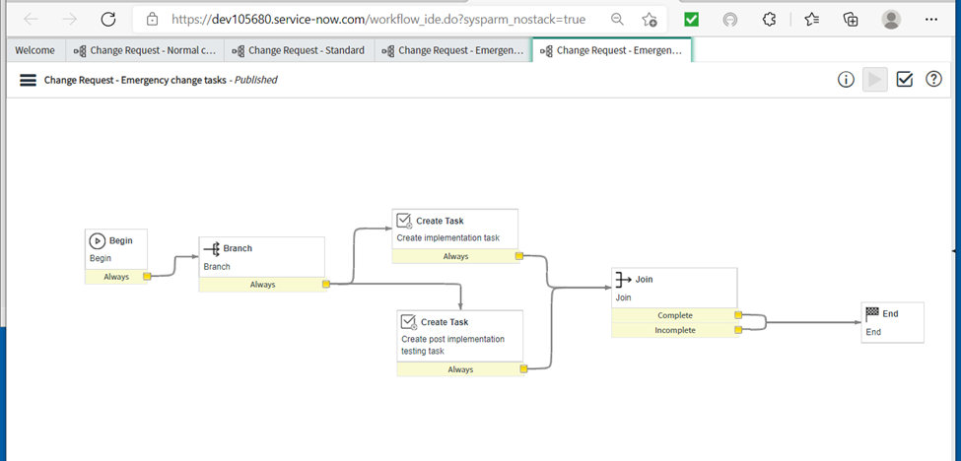

## 

## 

## 4.3 Normal Change

### 4.3.1 Normal Change Flow

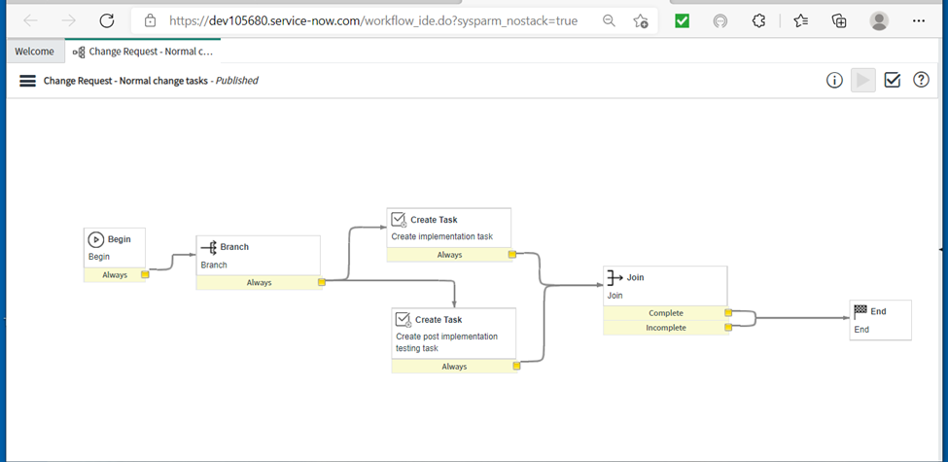

### 4.3.2 Normal Change Tasks

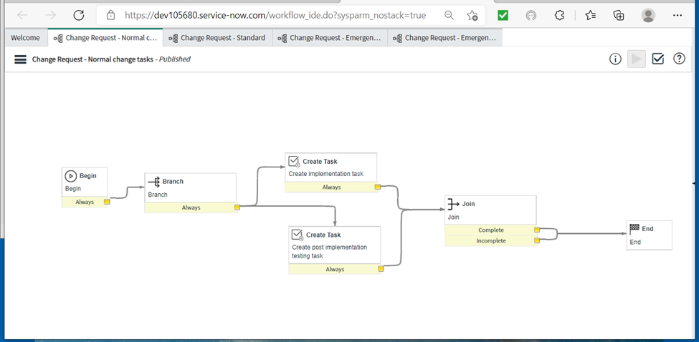

## 4.4 Major Change

### 4.4.1 Major Change Flow

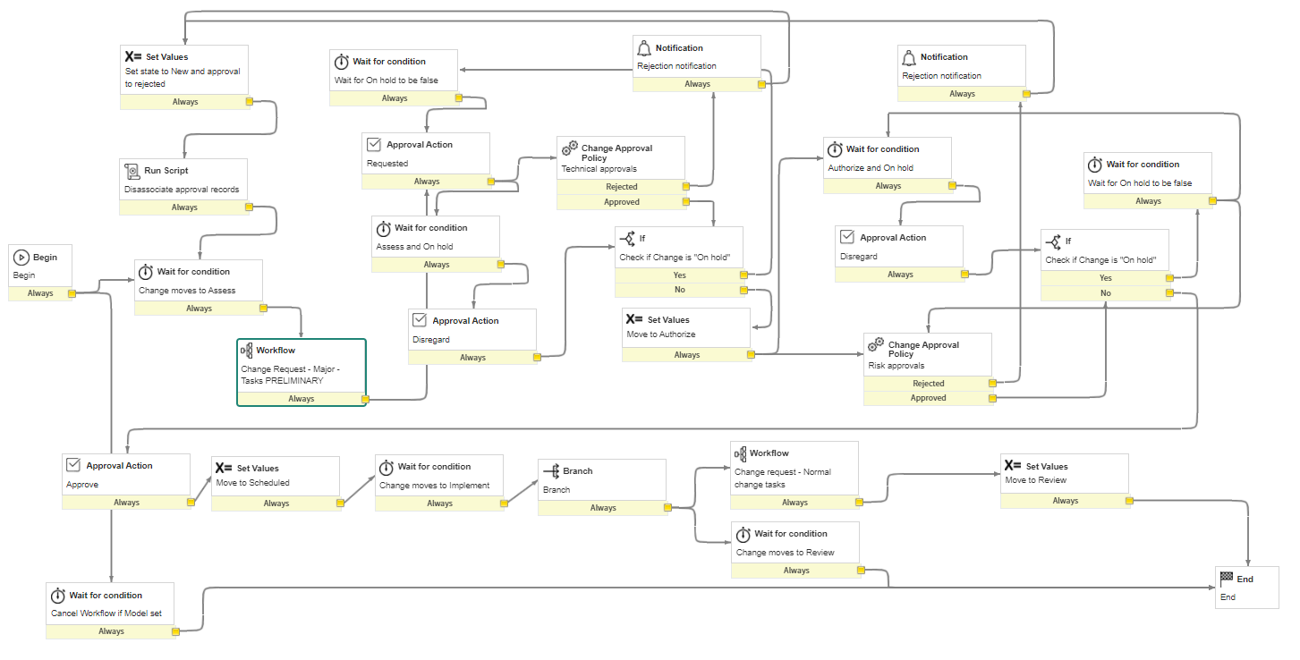

### 4.4.2 Major Change Task Flow

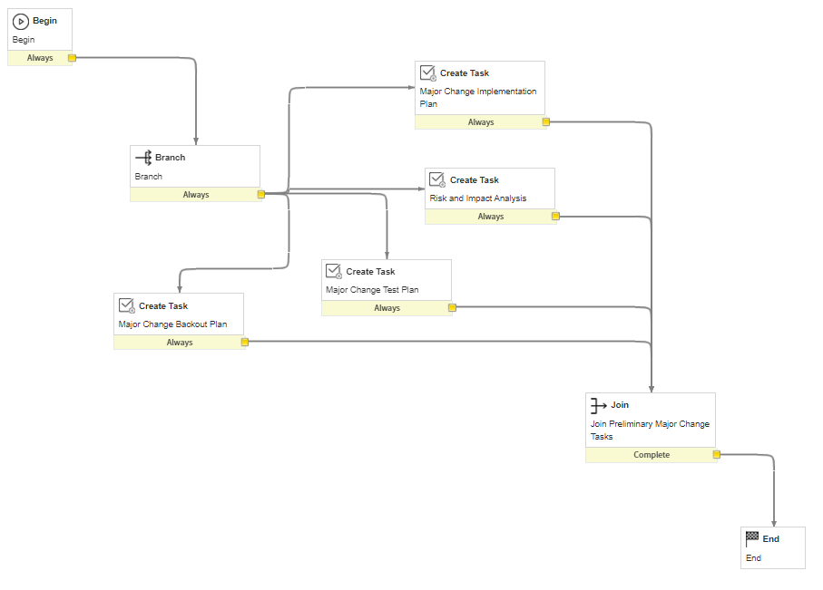

Major Change Task Flow also implements 4.3.2 Normal Change Task Flow

# 

# 5 Notifications

| **Action** | **Conditions** | **Event** | **Subject** | **Body** |
| --- | --- | --- | --- | --- |
| Record Inserted | none | Send email to Requested by | New Change #Change ID | Your change request (change ID) has been submitted. Request will be processed ASAP. |
| Record Updated | Department is Anything | Send email to Department | New Change #Change ID | Your group has been assigned a new change (change ID). Please log in to ServiceNow to view. |
| Record Updated | CAB required is True | Send Email to CAB | New Change #Change ID requires approval | Change request (change ID) requires CAB approval before it can proceed. Please process ASAP. |
| Record Updated | CAB decision is approved or CAB required is false | Send Email to Group | Change #ChangeID has been approved | Change request (Change ID) has been approved. Please complete the change process. |
| Record Updated | State is one of Closed or Canceled | Send Email to Requested By | Change #ChangeID has been processed | Change request (Change ID) has been processed. Thank you. |

# 

# 6 Overview

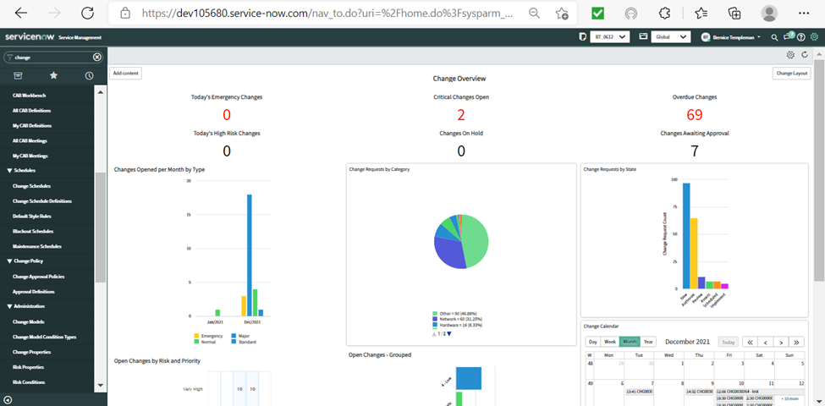

## 

## 6.1 Save Chart

Right click top right corner of chart and save as PNG or JPEG.

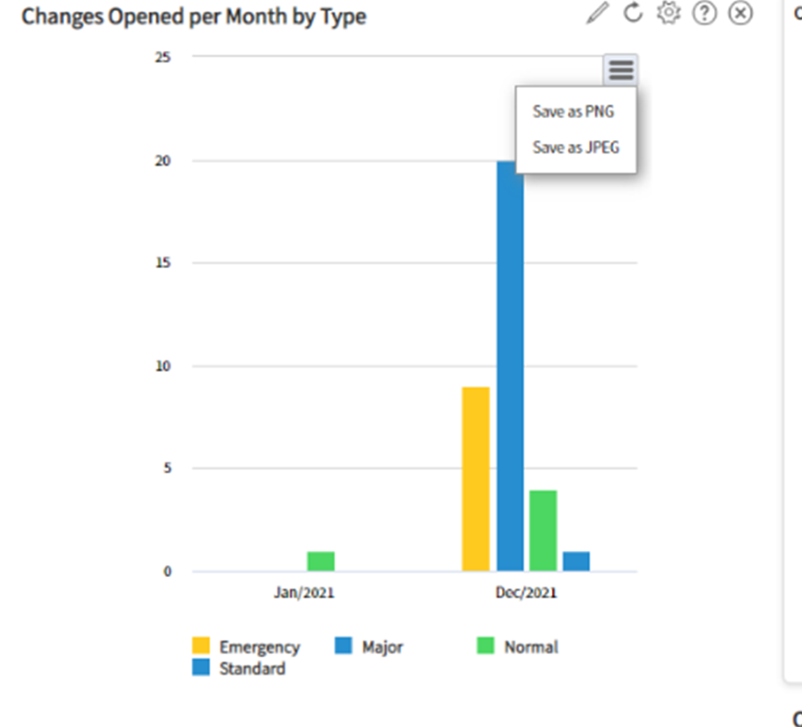

## 

## 6.2 Print Form

The form context menu provides controls based on the table and user access rights. Administrators can customize some of the options available on a context menu using UI actions.

Access the form context menu by clicking an icon beside the form title or by right-clicking the form header (Context menu icon).

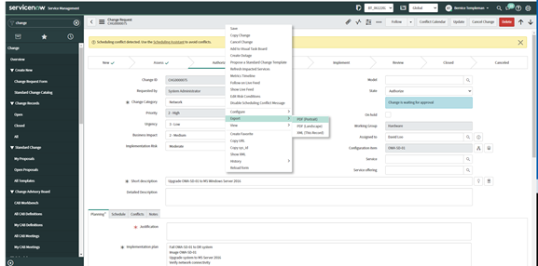

## 6.3 Print Change List

Right click on a column heading.

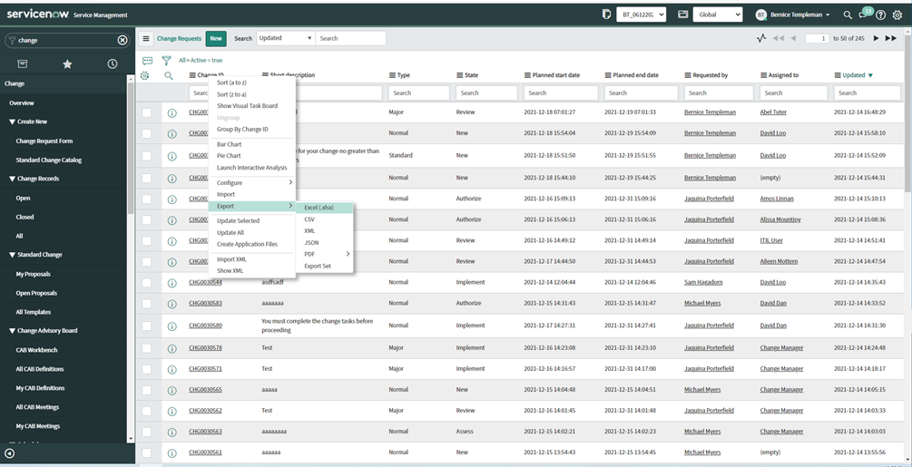

# 

# 7 References

ServiceNow. (2021, July, 22). *Add a new change type.* <https://docs.servicenow.com/bundle/rome-it-service-management/page/product/change-management/task/t_AddNewChangeType.html>

ServiceNow. (n.d.). *Best practices.* <https://www.servicenow.com/content/dam/servicenow-assets/public/en-us/doc-type/success/quick-answer/customization-best-practices.pdf>

ServiceNow. (2021, July, 22). *Change types*. <https://docs.servicenow.com/bundle/rome-it-service-management/page/product/change-management/concept/change-types.html>

ServiceNow. (2021, July, 22). *Change request states.* <https://docs.servicenow.com/bundle/rome-it-service-management/page/product/change-management/task/state-model-activate-tasks.html>

ServiceNow. (2021, July, 22). *Process a change request.* <https://docs.servicenow.com/bundle/rome-it-service-management/page/product/change-management/task/t_ProcessAChangeRequest.html>

ServiceNow. (2021, July, 22). *State model and transitions.* <https://docs.servicenow.com/bundle/rome-it-service-management/page/product/change-management/concept/c_ChangeStateModel.html>

ServiceNow. (2021, July, 22). *Create a UI action.* <https://docs.servicenow.com/bundle/rome-platform-administration/page/administer/list-administration/task/t_EditingAUIAction.html>

ServiceNow. (2021, July, 22). *UI policies.*  <https://docs.servicenow.com/bundle/rome-platform-administration/page/administer/form-administration/task/t_CreateAUIPolicy.html>

ServiceNow. (2021, July, 22). *Business rules.* <https://developer.servicenow.com/dev.do#!/learn/learning-plans/rome/servicenow_application_developer/app_store_learnv2_scripting_rome_business_rules>

ServiceNow. (2021, July, 22). *Script includes.* <https://developer.servicenow.com/dev.do#!/learn/learning-plans/rome/new_to_servicenow/app_store_learnv2_scripting_rome_script_includes>

ServiceNow. (2021, July, 22). *Client Scripts*. <https://docs.servicenow.com/bundle/rome-application-development/page/script/client-scripts/concept/client-scripts.html>

ServiceNow. (2021, July, 22). *Create a change request from a CI.* <https://docs.servicenow.com/bundle/rome-it-service-management/page/product/change-management/task/t_CreateAChangeFromACI.html>

ServiceNow. (2021, July, 22). *Create a change request from an incident.* <https://docs.servicenow.com/bundle/rome-it-service-management/page/product/itsm-workspace/task/create-change-from-incident.html>

ServiceNow. (2021, July, 22). *Create a change request from a problem.* <https://docs.servicenow.com/bundle/rome-it-service-management/page/product/problem-management/task/fix-a-change.html>

ServiceNow. (2021, July, 22). *Copy a change request.* https://docs.servicenow.com/bundle/rome-it-service-management/page/product/change-management/task/copy-a-change-request.html

ServiceNow. (2021, July, 22). *Add and manage attachments.* <https://docs.servicenow.com/bundle/quebec-platform-user-interface/page/use/using-forms/task/t_AddingAnAttachment.html>

ServiceNow. (2021, July, 22). *Creating reports.* <https://docs.servicenow.com/bundle/rome-now-intelligence/page/use/reporting/reference/report-types-creation-details-rd.html>

ServiceNow. (2021,July22). *Create* *a change request.* <https://docs.servicenow.com/bundle/rome-it-service-management/page/product/change-management/task/t_CreateAChange.html>

ServiceNow. (2021,July22). *View management.* <https://docs.servicenow.com/bundle/rome-platform-user-interface/page/administer/navigation-and-ui/concept/view-management-overview.html>

ServiceNow. (2021,July22). *Form context menu.* <https://docs.servicenow.com/bundle/rome-platform-user-interface/page/use/using-forms/concept/c_FormContextMenu.html>

ServiceNow. (2021, July 22). *Customize list v2 context* *menus*. <https://docs.servicenow.com/bundle/rome-platform-administration/page/administer/navigation-and-ui/task/t_CreateAContextMenu.html>

ServiceNow. (2021, July 22). *Place a change request on hold* <https://docs.servicenow.com/bundle/rome-it-service-management/page/product/change-management/task/t_PlaceAChangeRequestOnHold.html>

ServiceNow. (2021, July 22). *Change advisory board (CAB) workbench).* <https://docs.servicenow.com/bundle/rome-it-service-management/page/product/change-management/concept/cab-workbench.html>

ServiceNow. (2021, July 22). *Change approval policies*. <https://docs.servicenow.com/bundle/rome-it-service-management/page/product/change-management/concept/change-approval-policy.html>

* ~~remove tabs we dont need~~
* ~~once closed or cancelled should not be write notes or update (this looks done )~~
* ~~no new stuff after closed or cancelled (I checked a closed and cancelled and this looks done- bernice)~~
* ~~possibly change watch list to subscribers list(ask zach)~~
* ~~assign it to someone- Bernice- auto -assigned to creator- this is currently readonly-~~
* ~~add manager to group or assigned to - standard was autoassigned to david loo /Bernice… Normal group was auto-assigned… and assigned to can be added/bernice~~
* ~~assigned to can only work on change request sam~~
* tasks cannot be completed without assigned to sam
* remove unnecessary views bernice/ other groups still have views/ more than change/ checking on the view types
* ~~make none onload for category~~
* cannot access from new insert sam
* take out new from all states after new sam
* only make it able to approve for approver sam
* ~~make review button show only when tasks are completed//added br to give error message to complete tasks/ Bernice~~
* ~~from review should be able to back out to implement~~
  1. All types can go back to implement not sure about who can send it back to implement
* ~~Cannot review without completing tasks~~
* Make implement button appear on scheduled state

testing/bernice

* ~~User ‘Change.Manager’ can close or send back to implement~~

<https://uit.stanford.edu/sites/default/files/2017/11/22/Change%20Management%20Fulfiller%20guide%20-%20Final%20-%20Version%201%20%281%29.pdf>

- Number – A unique number identifying the Change record in the system (auto-assigned)

- Requested by – The individual who submitted the initial Change request. The person who reported or is affected by this request.

- Affected CI – The configuration item or business service affected by the change. - CAB Supported

– Flag set by Change Management Group to indicate Change Request was approved in a CAB meeting. If checked, CAB approval will be skipped for the Change request.

- PIR (Post Implementation Review) – Members of the Change Management group select a value for this field. It is a dropdown field that indicates the status of the Post Implementation Review. Options are None, Required, In Progress and Completed. All Emergency Change Requests require a PIR.

- Risk/Impact – A calculated field based on the answers supplied in the Risk Assessment tab. See https://uit.stanford.edu/service/changemgt/impacts_risks for more information. - Short Description

– A short description of the Change Request.

- Description – A detailed description of the change request. Enter what this change is and why this change is being made. Include the benefits of implementing this change and the impact if this change is not implemented.

- Type – [auto-set based on lead times and type of change requested] The type of Change. Options are Normal, Expedited, Emergency, Informational, and Standard. Click on the field label ( ) to see full description of the different types of change.

- Approval – This field indicates the status of the Change Request’s approval. When the Change is first created and in Draft State, it will have an approval value of Not Yet Requested. When the first approval is requested from the Assignment Group’s manager, the Approval state will change to Requested. The state of the Approval will only change to Approved after all approvals have been completed. If at any point the Change is rejected, the Approval state will be Rejected and the overall State of the Change Request will be reset to Draft.

- Conflict Status – Indicates whether other Changes are scheduled to occur at the same time as the current change. Use the Conflicts tab lower on the form to check for and review conflicts. Conflicts are not “blockers” i.e. that the Change cannot be scheduled then, but should be reviewed and considered for possible impacts.

- Conflict last run – Indicates the date and time when conflicts were last checked using the Conflicts tab. If the Planned Start Date, Planned End Date, or Affected CI change, the system automatically checks for conflicts again whenever the change form is saved or submitted.

- Assignment group – The group assigned to implement the Change.

- Assigned to – The individual stakeholder ultimately accountable for the end result of the Change, seeing it through its lifecycle. The person primarily responsible for working this Change Request